HS8 Midi Program
Nov 2018

Table of Contents

General

HS Midi Player

This program was written originally to save the registration memory buttons and to be able to re-load them at a later date, and now does more. It emulates the Music Disk Recorder (MDR).

HS-Midi-Player.exe and HELP file
This software is produced and distributed by:
Gyro Productions --- garry (at) smith.net
Western Australia

IMPORTANT
This software is designed for use on IBM compatible personal computer systems running Windows XP, Windows Vista, Windows 7, 8 and 10 operating systems. It doesn’t need installing or does it alter the REG file in your operating system, just execute the .exe file.
The software may be transferred from one personal computer to another without the consent of Gyro's Productions.
Refer to the DISCLAIMER (below) in this manual before attempting to use this software.

Disclaimer
The HS Midi Player software and documentation is distributed 'as is', without any expressed or implied warranties what so ever. The user must assume the entire risk in using the software. Gyro Productions shall not be liable for loss of data, loss of profits, and damage to personal or public property, injury of any type, death or disablement, or any other incidental or consequential damage. The manufacturer reserves the right to change the software and/or documentation without obligation to notify any person or organization of such changes.

Introduction

1.1 Overview
This program saves the data from the Yamaha Electone Models HS4, HS5, HS6, HS7 and HS8 to the drives on your PC, I have tested it with the HS6 and HS8, data files can be reloaded back to the Electone. The reason I called the first program “HS8-Midi” was that I wrote it first for the HS8 then realized it does work with other Electones so now have renamed it to “HS-Midi-Player”.

Hardware and Software Requirements

HS-Midi-Player is designed for use under the Microsoft Windows 32bit and 64 bit operating environments. It has been tested in operation under Windows 7 and Windows 8 and Windows 10.
The software does not need to be installed, and can be executed from any hard drive or portable drive on the computer and requires approximately 1mb of disk space for the files. Saved data will increase the space required marginally. Alternatively the software can be run from a removable device such as a USB thumb drive and operated entirely from that device.

2.1 Software Licenses
HS-Midi-Player software is not copyright protected and can be at the moment, distributed at will.

2.2 Software Warranty
The HS-Midi-Player software comes with a NO warranty. If the software does not perform to your expectations, it would be appreciated that you can contact us so as we may be able to correct the BUG.

Copyright

This software is not copyright(ed) or licensed. Therefore the software or (any part of the software or data) may not be sold but I do encourage that it be distributed at will. If you are a keen VB programmer, I can forward the Visual Basic solution file to you if you want to alter or change its facilities but I request you give it another name.

Getting Started for the first time

Installation

There are a two files that are required, if you don't want to have the program place in your start up menu, the easiest way to install it is, using windows explorer or a program similar, to create a folder on your main drive which is usually C:/ and create a new folder called "HS-Midi", then in that folder (C:/HS-Midi) place the 2 files required:-

HS-Midi-Player.exe
User Manual.chm

Now you create a shortcut from your desktop to run the program, to do this, right click the mouse on the desktop and browse to the file (C:/HS-Midi/HS-Midi-Player.exe and click on that file, then NEXT and if you want to can change the name on the desk top (I usually leave as is) then FINISH and that’s it. If you double click on the desk top ICON and it tries to work, but comes up with windows error, the windows update haven't been kept up to date, I have not experience this but I read it somewhere.
The software may be loaded onto any drive, even from a USB memory stick (including network drives) with the required disk space available.
Before the program will work to the Yamaha, you will need to purchase a USB to midi cable, I got the UM-ONE mk2 by ROLAND and it works well, cost about $60 AU when I got it, follow the information to load the drivers into you PC for the midi cable, with Win10, once plugged in, Win10 will find and install the driver automatically, then just plug the USB side into your computer USB and the MIDI IN and MIDI OUT cords into your Yamaha midi ports, you should be now ready to fire up the program. I have used it on Win7, Win8 and Win10.

Main Window

This is how the main window looks after you execute the HS-Midi-Player.exe file with out and USB-Midi driver or organ connected, you will get three errors as shown in Fig. 1, 2 and 3 before you get to Figure 4.
.
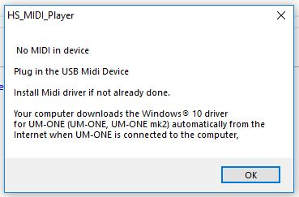
Figure 1. - No USB to Midi cord detected

If you have no MIDI Driver loaded or no MIDI USB cord.

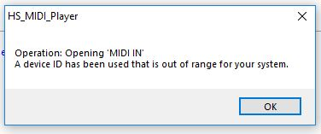
Figure 2. - No USB to Midi cord detected

If you have no MIDI Driver loaded or no MIDI USB cord.

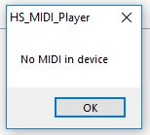
Figure 3. - No USB to Midi cord detected

If you have no MIDI Driver loaded or no MIDI USB cord.

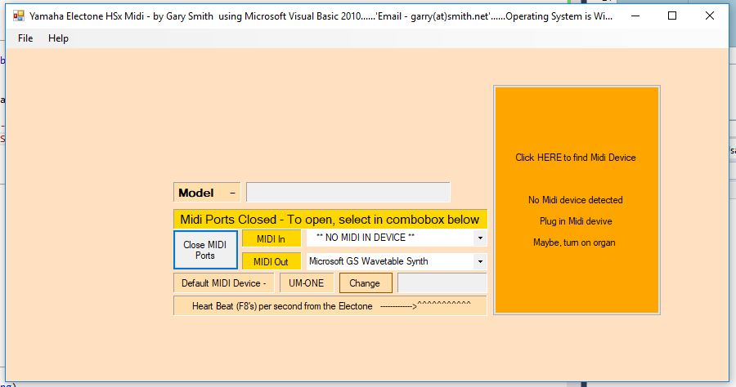
Figure 4. - USB to Midi cord not connected

If you have no MIDI Driver loaded or no MIDI USB cord.

Once you have connected the MIDI USB cord and loaded the drivers, all should be sweet. If you have the USB-Midi cord plugged in but the organ is turned off or not connected you will go straight to this screen in Figure 5.

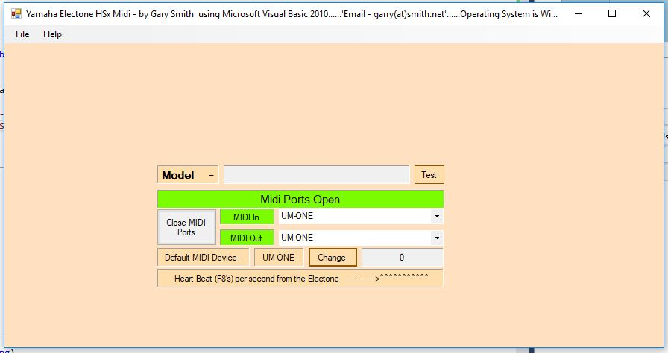
Figure 5. - USB to Midi cord detected but not organ

Midi Ports Setup

If you don’t get the “Midi Ports Open” in the message box, make sure you have the cords plugged in and the Yamaha turned on, should have one LED on the UM-ONE (USB) with if connect to your computer, then two LEDS (USB and IN) with the Yamaha turned on then all three LEDS (USB, In and OUT) when you execute the program HS-Midi-Player.exe and it connects to the program, if not, then you may have to select the MIDI IN and MIDI OUT ports to have UM-ONE in both those textboxes, to test that the program is talking to your Yamaha, press the TEST button and it should put you ELECTONE model in the MODEL textbox, if so, your away and running. Make these settings the default, this save these settings for the next time you execute the program. The main screen should look like figure 6. If you click the “TEST” button and the organ isn’t connected or turned on, you will get the error as in Fig 6.

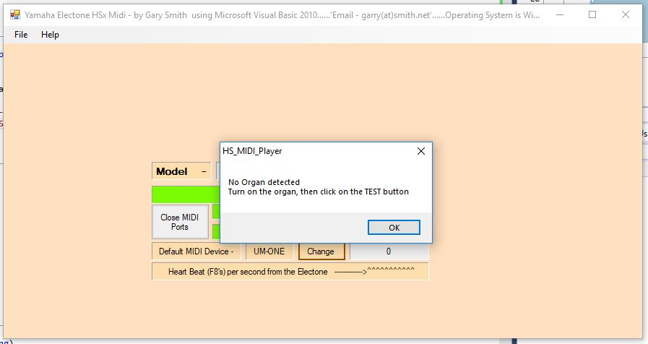
Figure 6. - Midi ready but organ not connected
If you have all turned on and connected, then it will go to the screen as shown in Fig 7.
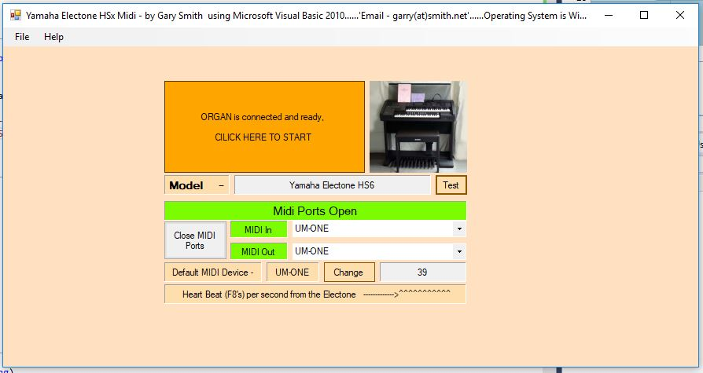
Figure 7. - Ready to go and play
Now just click on the Orange start button or the picture of the organ and you will go into the main USER SCREEN as shown in fig 8.
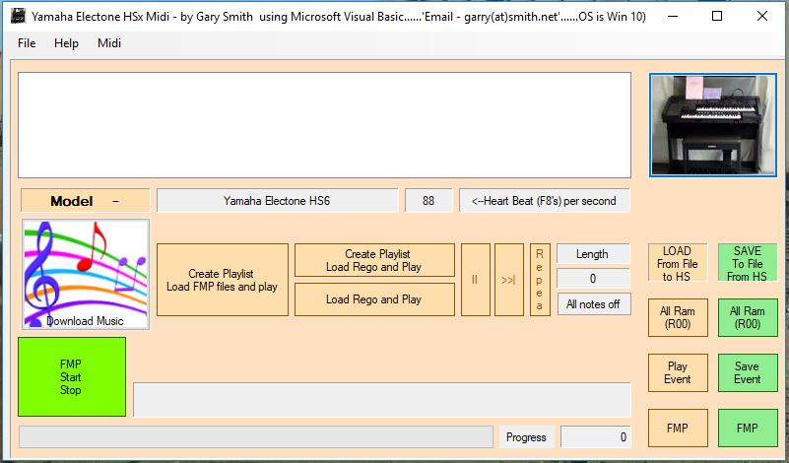
Figure 8. - Main users screen, ready to play
You will see the model of the organ (Yamaha Electone HS6 in this help file) and the organs’ heart beat (in this case 38).

How to use the program.

Playing your first repertoire

File Structures

All the data, like the registration memory button or sometime referred to as “Stops” (like in the pipe organ days) and any other setting on the organ is saved in the file ending (or file extension name) is .R00 e.g. Jinglebells.R00 and all the notes and effects are saved as a file with an extension name of .EVT or known as an event file, for the song to play, these two file have to have the first names the same, e.g. Jinglebells.R00 and Jinglebells.EVT.
The save FMP (Full music Programmer) and load FMP buttons also save or load files that containing CSP, RSP, FMP or REG data.

Downloading R00 and EVT files from the internet.

These file have been created from other talented artists and can be got from the following sites:-
http://www.ggbmusic.com/hs8/index.html#Thunderbolt
http://mdreliminator.yolasite.com/

If you click on the colourful button, it contains a link to the music web site.

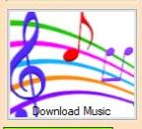

Registration and Event files.

The .R00 (Registration) files and/or the .EVT (Event) files can be saved or loaded separately depending what you are doing.

Load Registration Data (R00).

After you have saved your registration data to reload at a later date, or you want to load someone else’s registration data, this is done by the pale orange button marked “All Ram (R00)” which is located under the label “LOAD File from File to HS”, press this button and it will open the file explorer, the pick your file (default extension is .R00) and then load.
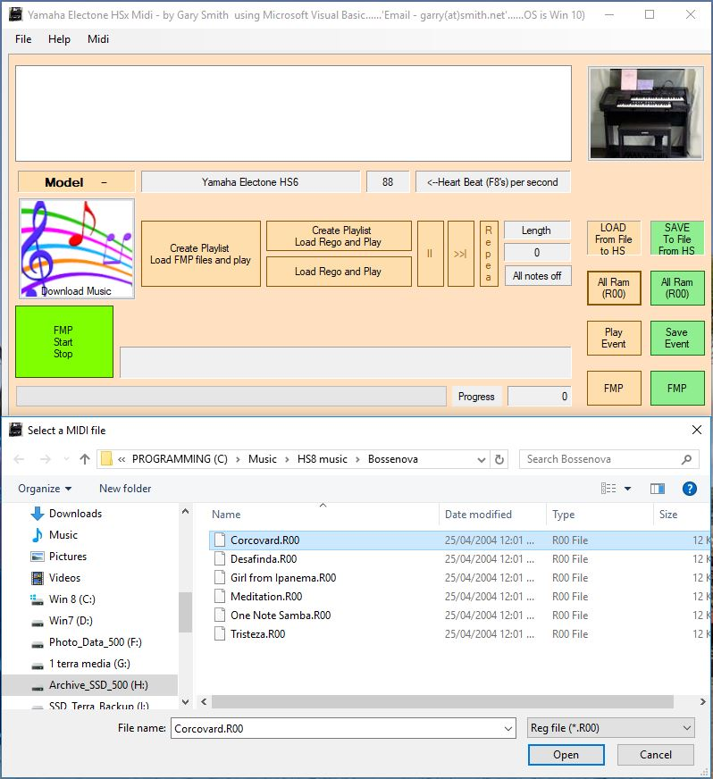

Figure 9. - Loading a single R00 file

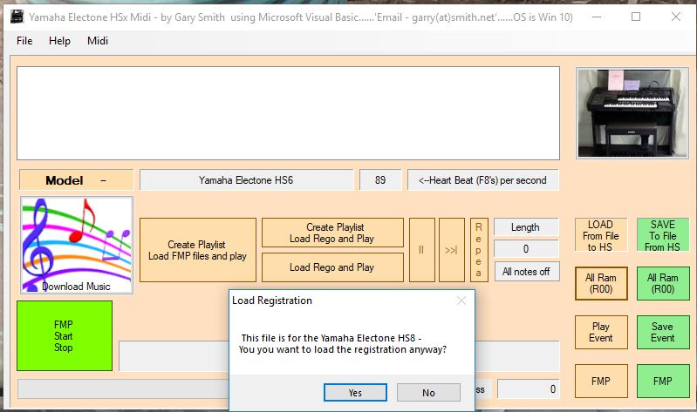

Figure 10. - After loading a single R00 file

If the file is made for a different Electone, then it gives a message, you can still try to load it and play the song but I know there are differences in the models. My HS6 doesn’t play the HS8 songs as good.

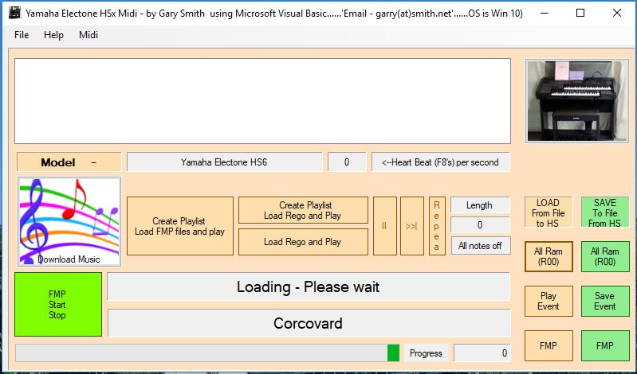

Figure 11 - Sending the R00 file to the organ.

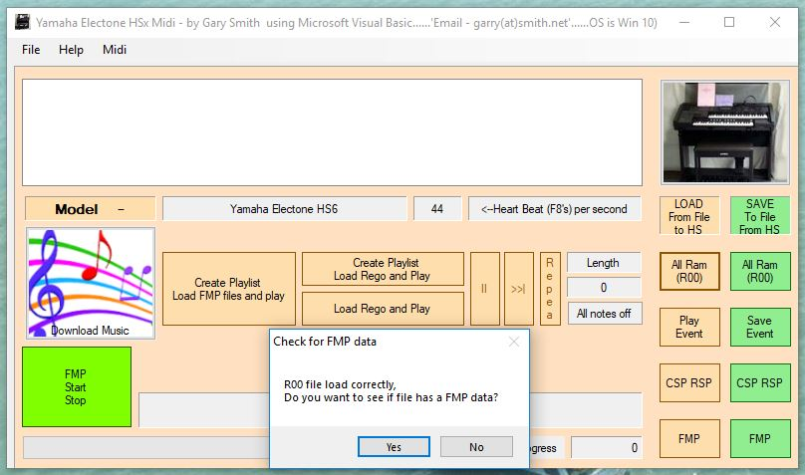

Figure 12. - After sending a single R00 check.

The registration (R00) data is now loaded into the organ and may contain FMP, CSP, RSP data so the program asks if you want to see if that is the case. If the green FMP button goes red and the organ plays, then there is FMP data.

Save Registration Data.
If you just want to save your registrations, this is done by the green button marked “All Ram (R00)” which is located under the label “SAVE to File from HS”, when pressed, it will ask you a name for the file and when the SAVE button is press, it save the registration data that is in your Electone to the file with the extension of .R00 to the subdirectory you pointed it to.
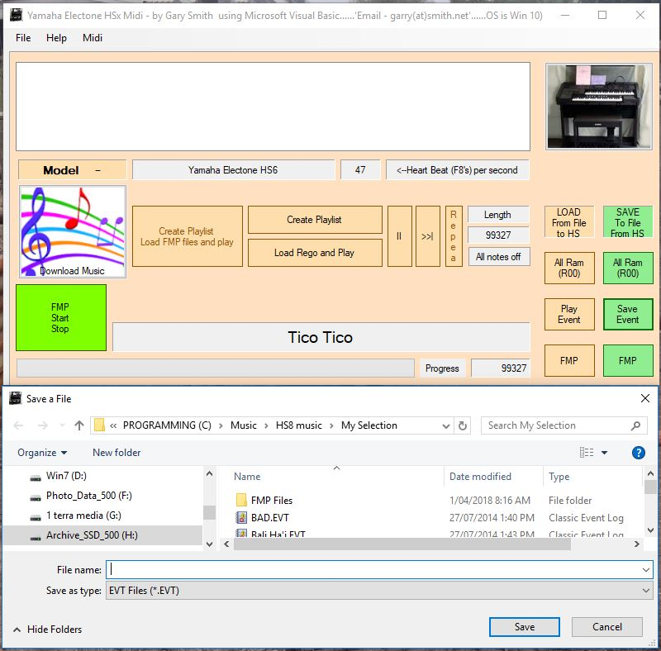
Figure 13. – Save registration file

Load EVT Data and Play.

To load, this is done by the pale orange button marked “Play Event” which is located under the label “LOAD File from File to HS”, press this button and it will open the file explorer, the pick your file (default extension is .EVT) and then it loads and plays.

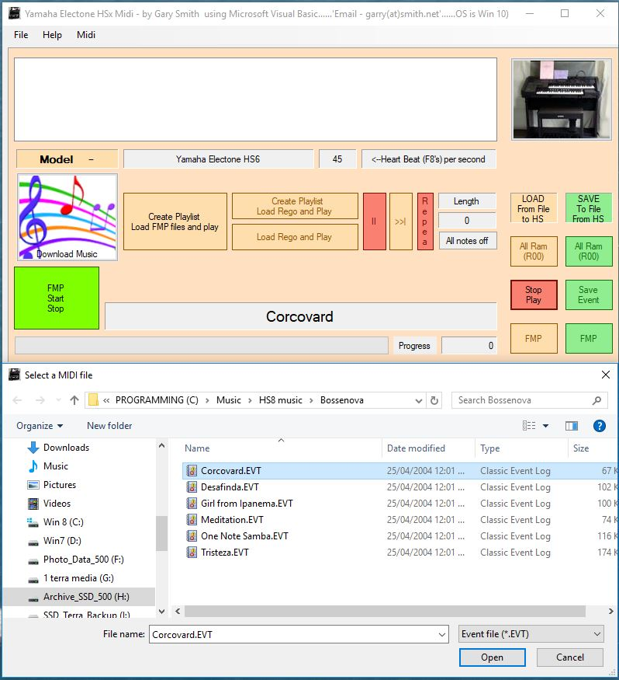

Figure 14. - Loading a single EVT file

After the organ starts playing the event file, you have a few options at this stage, the buttons you can use are now colours a dark pink, you can pause the music (“II” button), repeat the song, or use the Progress bar to go to a particular spot in the song by clicking on it, or stop the song with the “Stop Play” button.
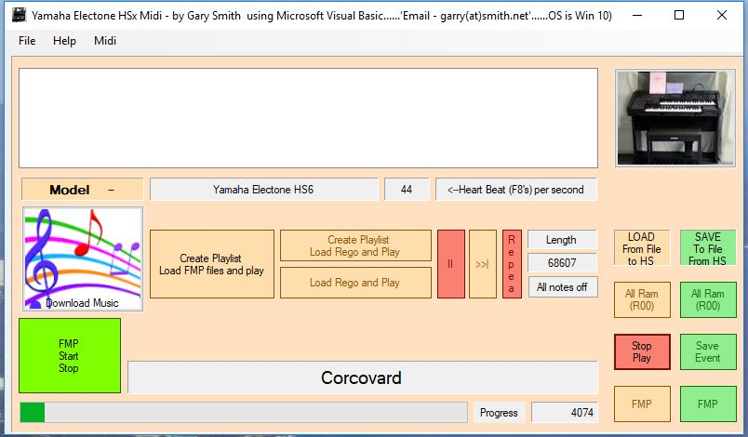

Figure 15. - Playing a single EVT file

Load Registration File and Play.

The easiest way to play a pre-saved repertoire, (that is, to load the registration file (R00) and play the event file (EVT)) is to click on the orange button “Load Rego and Play”, the program will first check that you have the MIDI ports open and the Electone connected and turned on, and gives you an indication if not, if so, will open the file explorer and then pick the song you want to play (See figure 16). The program loads the file name with a R00 file extension and sends it to the organ and then loads the same name file with an .EVT extension for the organ to play. Shown in Fig 16. , There is one thing that is needed for the files to be loaded, they need to have the same file preamble name, e.g. Jinglebells.R00 and Jinglebells.EVT and also be in the same subdirectory.
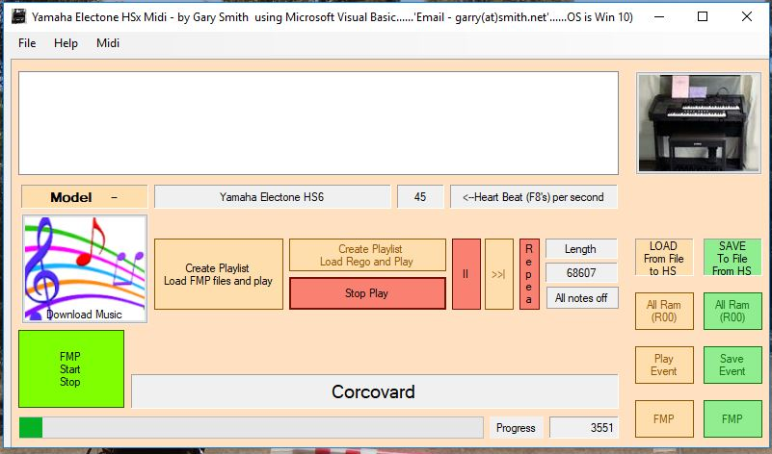
Figure 16. - Load Rego and Play

Sit back and enjoy....as single song ... or ...if you want, create a playlist, read on.

Create Playlist, Load Rego and Play.

I am assuming you have all the Midi ports working, by clicking this button, it will open the file explorer and then pick the song you want to play (Similar to figure 16). There is one thing that is needed for the files to be loaded, they need to have the same file preamble name, e.g. Jinglebells.R00 and Jinglebells.EVT and also be in the same subdirectory, all the songs in that subdirectory will be loaded and played, similar to the “Load Rego and Play Event” button, you have one more option and that is to go to the next song (“>>I”), see figure 17.
If the file/s is made for a different Electone, then it gives a message, you can still try to load it and play so if you click on “YES” then it will remember this and if the next file is made by a different organ, the it will load it without giving you the message.

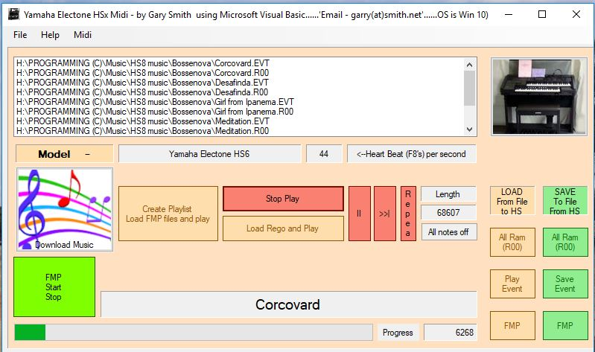

Figure 17 - Play a list of songs

Saving and loading CSP/RSP

If you have used the Chord Sequencing Programmer and the Rhythm Sequencing Programmer, then the best way to save the data complete is to save it via the “Save FMP” button to save all ram data and I have made it give the file name an .FMP extension. To load the CSP/RSP, use the “Load FMP” button. The other way to save CSP/RSP, is to click the green button “Save All Ram (R00)”, and maybe in the name, mention CSP or RSP, likewise to loading the CSP,RSP can be done using “Load All Ram (R00)”, you can save the individual CSP channels if you want but this can only be done in the hidden screen and really not worth saving this way(see Accessing the hidden test form figure 24).

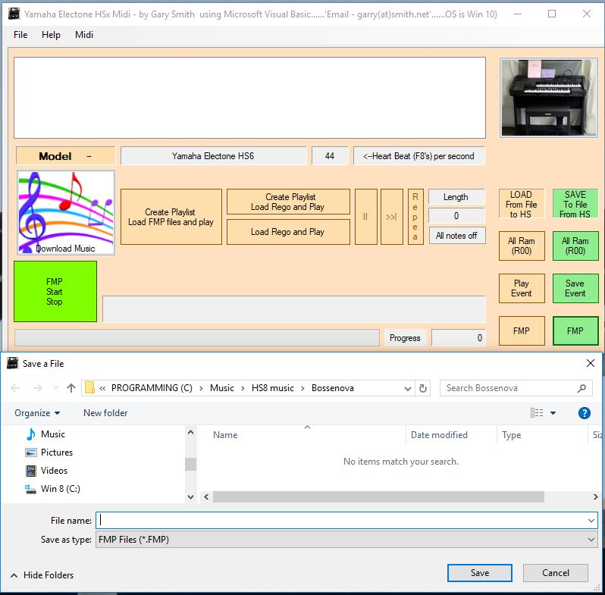

Figure 18. - Saving a FMP, CSP, RSP file

Saving Full Music Play (FMP) Files

Once you have finished recording using the FMP (Full Music Programmer), you can save it to hard drive, what I have done is made the “Save FMP” button to save all ram data and I have made it give the file name an .FMP extension. The other way to save the data complete is to save it via the green button “All Ram (R00)”, and maybe in the name, mention FMP, the file will have an extn of .R00 so it is hard to tell if it is just a registration file or what you have save it for. You can save the FMP data only, but is in the hidden part of the program, the reason why I did it like this was because it doesn’t save the other data such as memory buttons and registration.
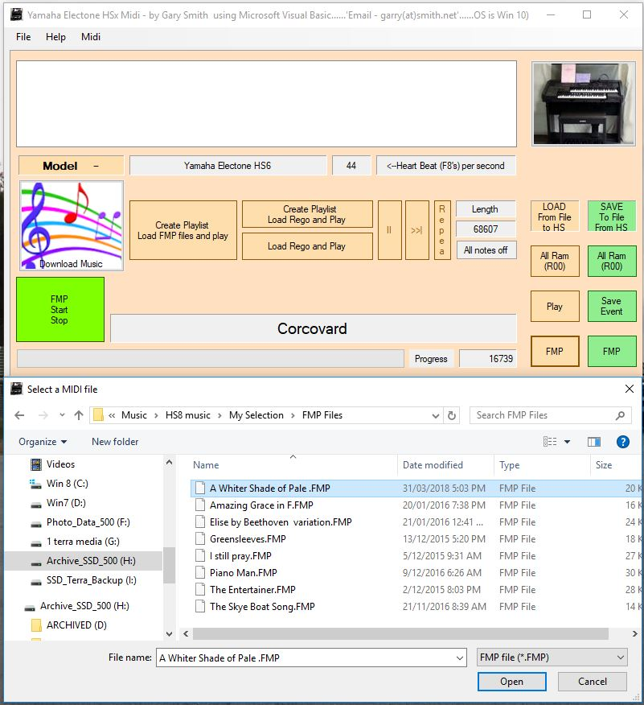
Figure 19. Loading a single FMP file
By Clicking on the “Load FMP” button, it will open the file explorer with a default extn of .FMP, then select the file you want and it will load the file from you hard drive and send it to you organ, then ask you if you want to play it, if you say “yes”, then it will automatically start playing, if you press “No”, then you can start the FMP manually by clicking the “FMP Start Stop” button and the button will turn reddish.
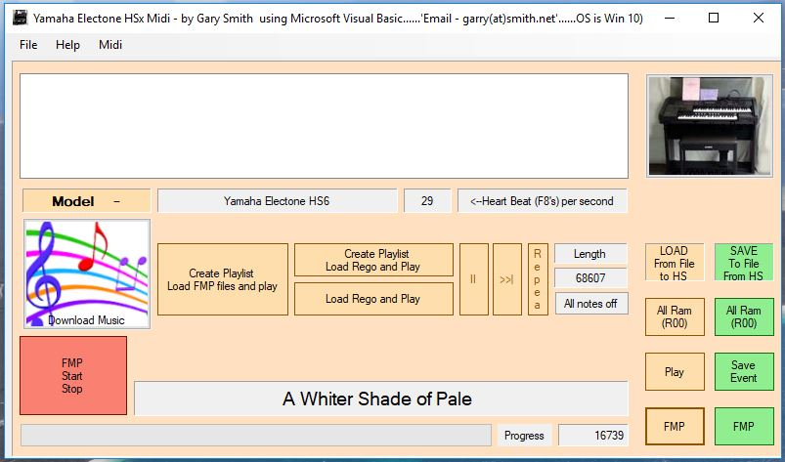
Figure 20. – Playing a single FMP file

Create Playlist, Load FMP data and Play.

If you have a number of FMP files you wish to play, then click on the “Create Playlist, Load FMP files and play”, it will open the file explorer with a default extn of .FMP and will make a list of all the FMP files in that subdirectory and begin to play them in the order thats in the list, you have options of “Next song” which goes to the next on the list or “Stop Play” which stops playing and exits the list.
If the file/s is made for a different Electone, then it gives a message, you can still try to load it and play so if you click on “YES” then it will remember this and if the next file is made by a different organ, the it will load it without giving you the message.

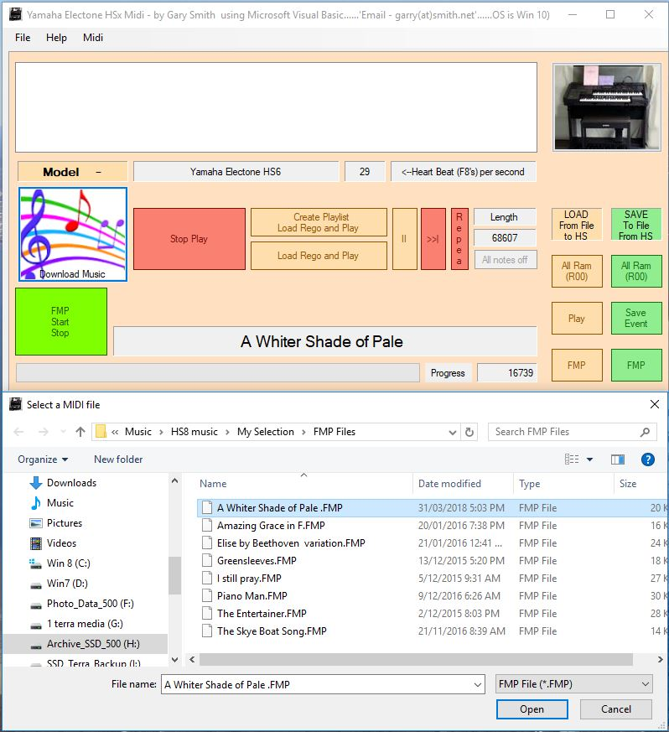
Figure 21. - Loading a FMP play list

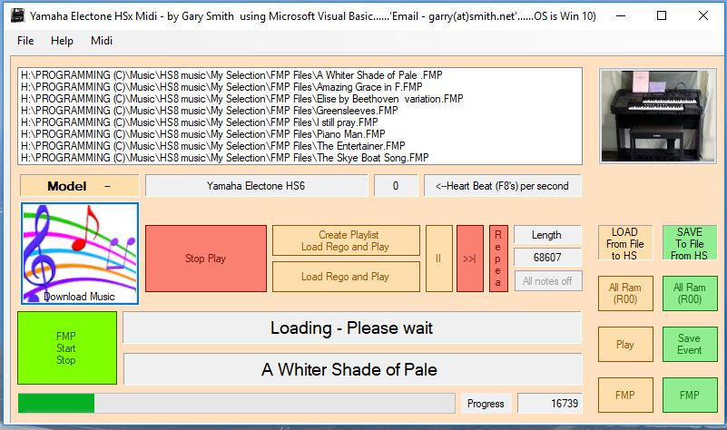
Figure 22. - Sending a FMP play list

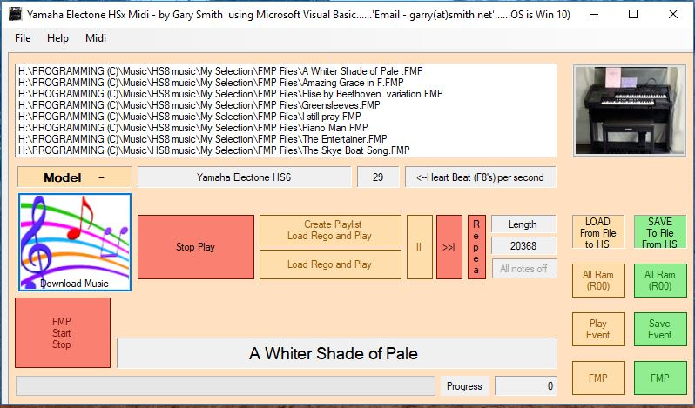
Figure 23. - Playing an FMP file from list

Other hidden Options for advanced users

Accessing the hidden screen.

This section or screen can be accessed by clicking on the picture of the organ, the screen size will be increased and show lots more buttons and list boxes for experimental use and checking data to and from the organ.
The help on this section is not yet finished.
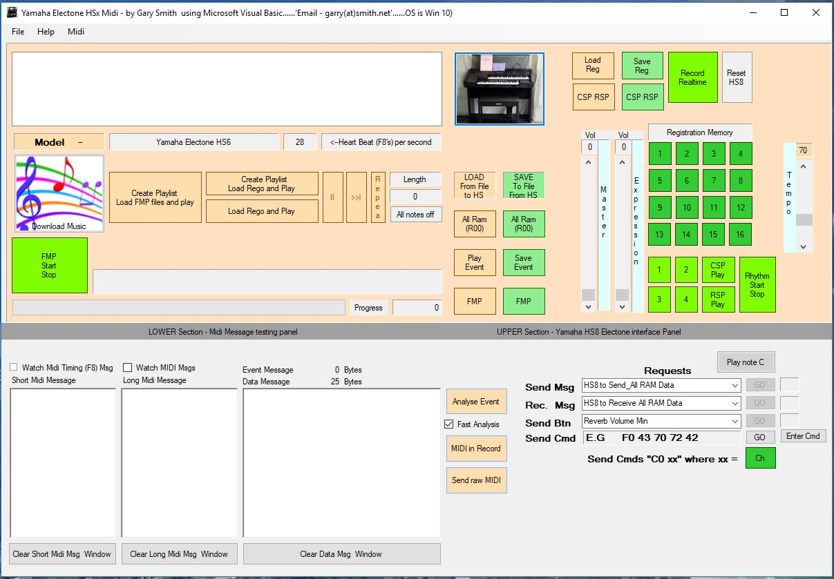
Figure 24. - Accessing the hidden testing form

Disclaimer

This program has been written in all good faith, please read this disclaimer.
COPYRIGHT NOTICE - This software and associated data
is not Copyright(ed) and can be shared around at will, please report any "BUGS" so as they can be corrected.
DISCLAIMER - This software is supplied "as is", without any expressed or implied warranties what so-ever. The user, in making use of this software, assumes the entire risk in using the software. The writer of this program shall not be liable loss of data, loss of income, loss of profits, damage to personal or public property, injury, or any of her incidentals or consequential damage.
Press the ACCEPT button below to acknowledge that you have read and understood the COPYRIGHT NOTICE, END USER LICENSE AGREEMENT and DISCLAIMER ", "information above, and accept these as conditions of use of this software.

Problems

I've read somewhere that if you try to run the program and it tries to work but comes up with windows errors, the windows operating system updates haven't been kept up to date, this program has been written using Microsoft Visual Studio 2010 then Microsoft Visual Studio 2017, it require a .NET framework of 4.5 or higher or it will come up with an error and ask you to update, this can be done quite easily.
Sometime if the MIDI USB cord is disconnected, the program gives an error, and the program won’t close, then press keys Ctr Alt Del go to Task Manager and Close Task.
Cheers and happy music.

